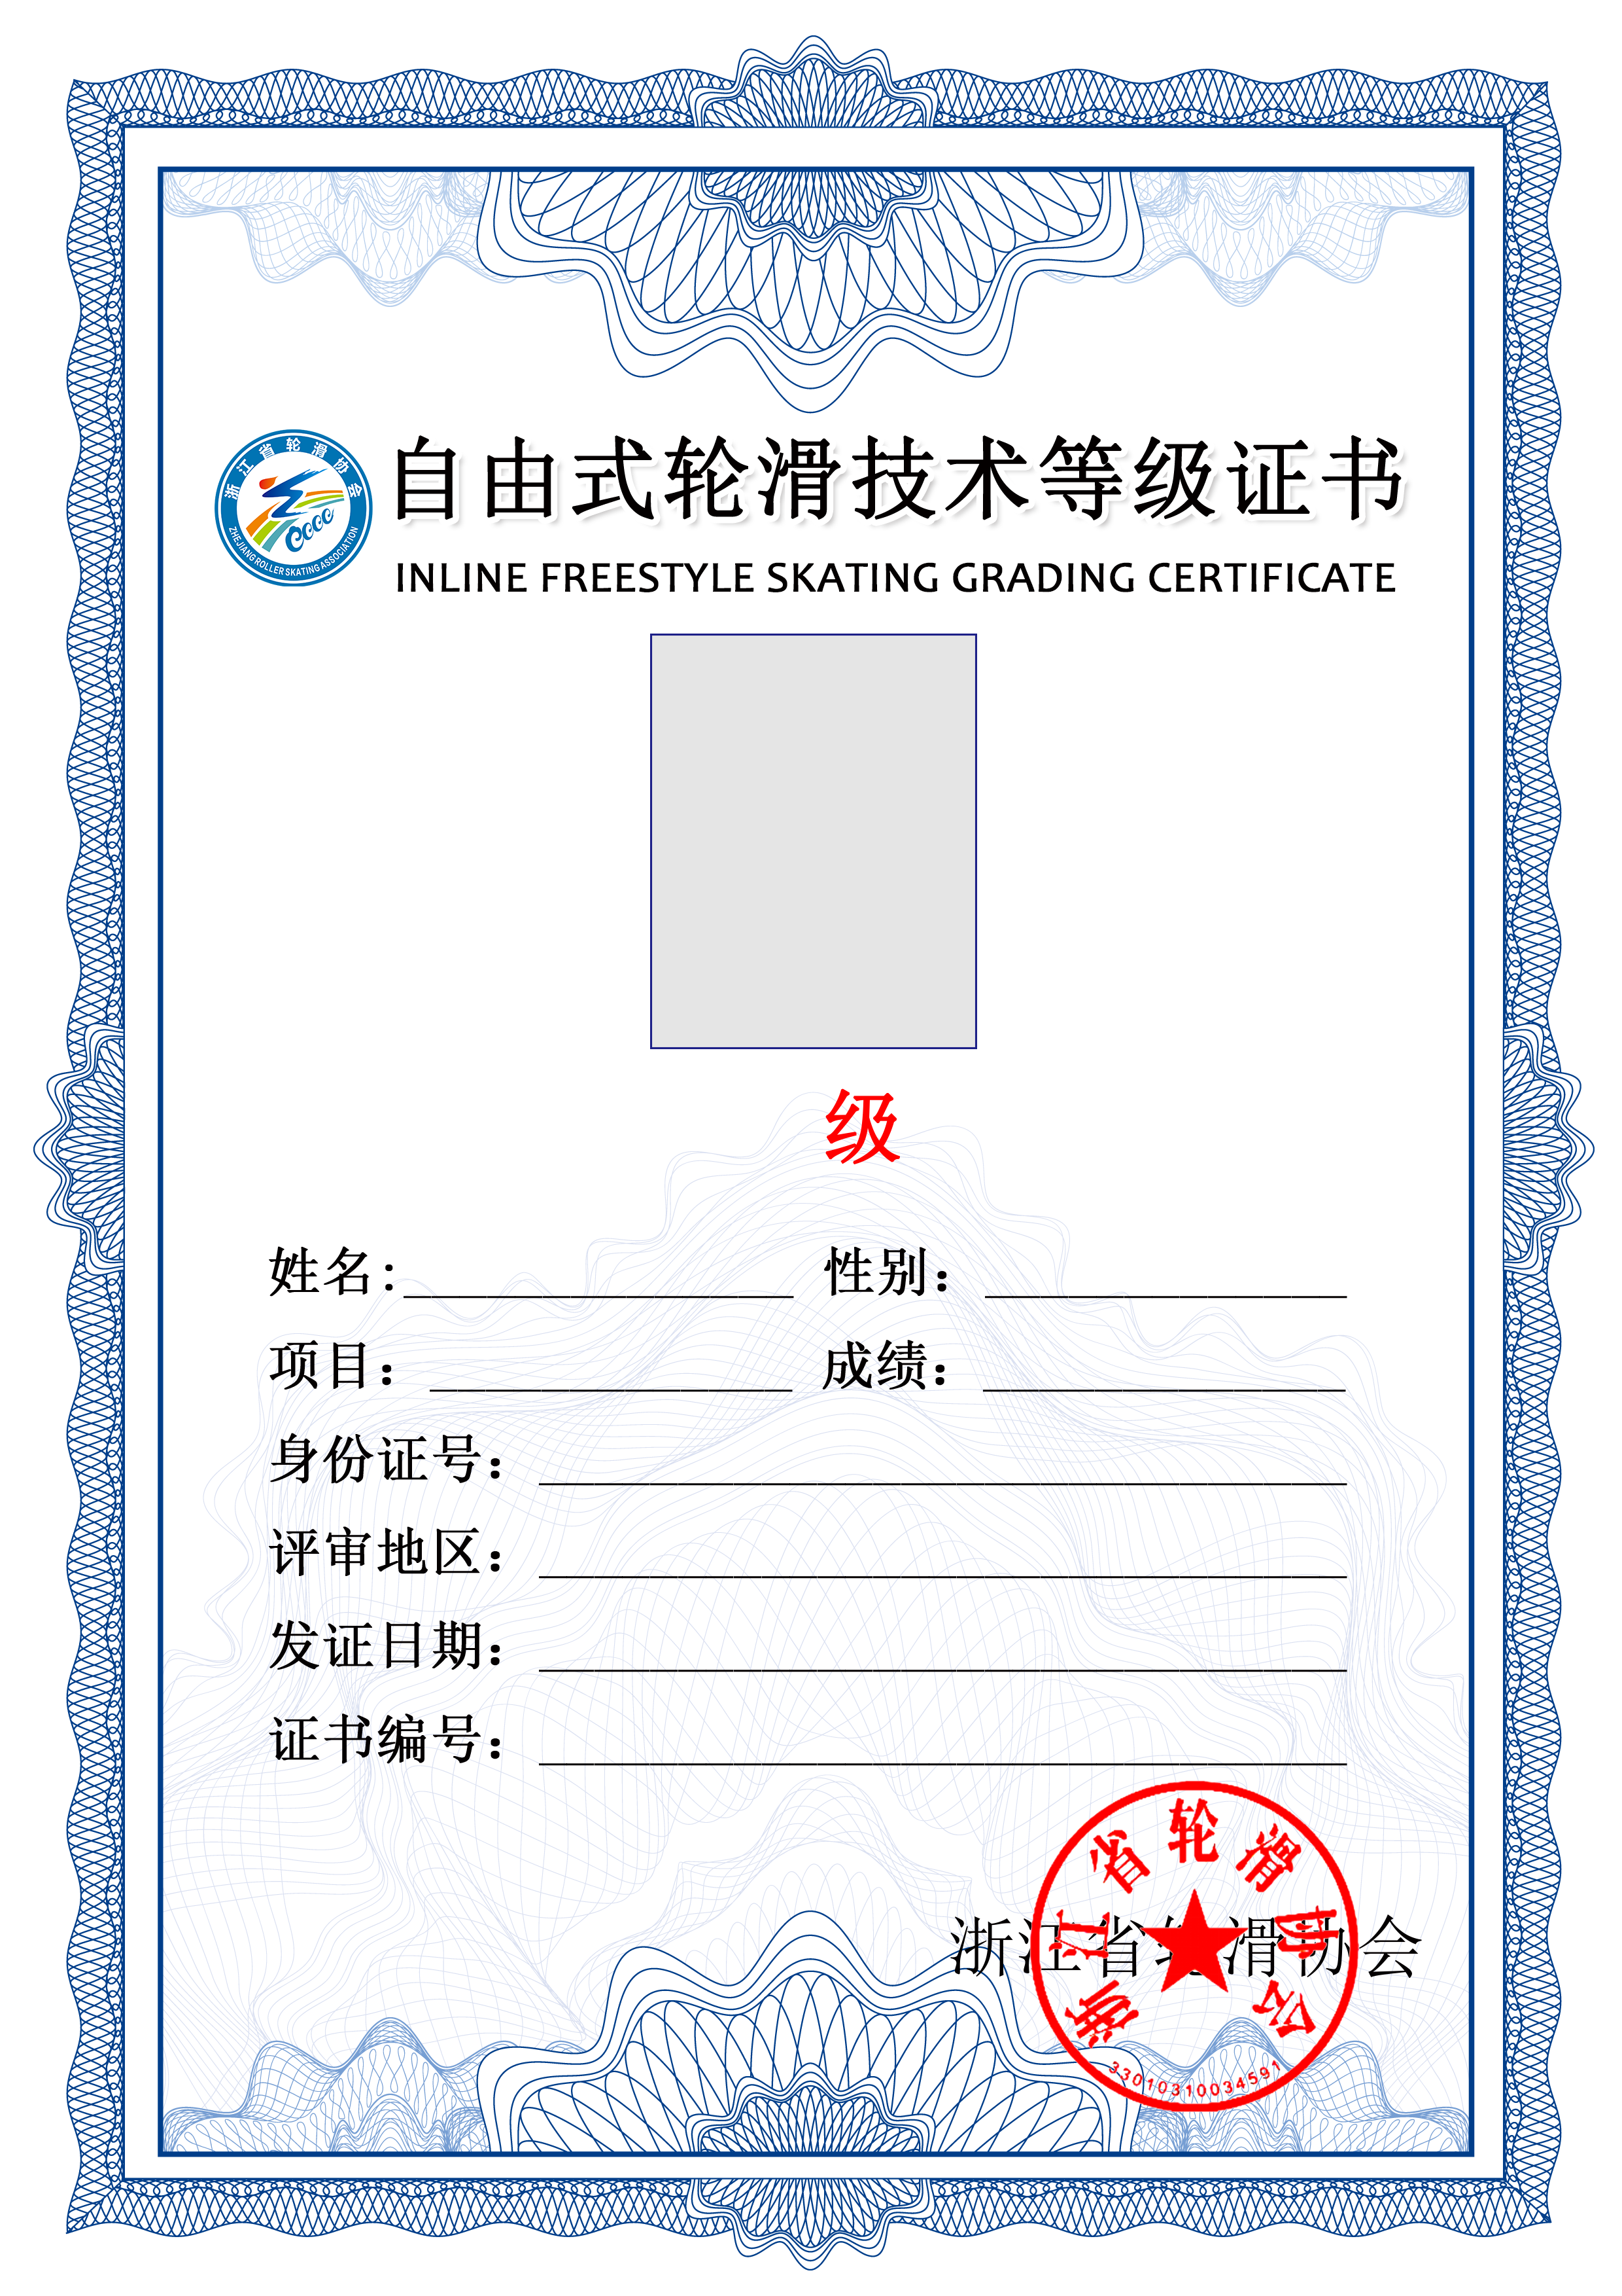

${照片}[100,150]

${等}

${证书编号}

${发证日期}

${评审地区}

${身份证号}

${成绩}

${项目}

${性别}

${姓名}