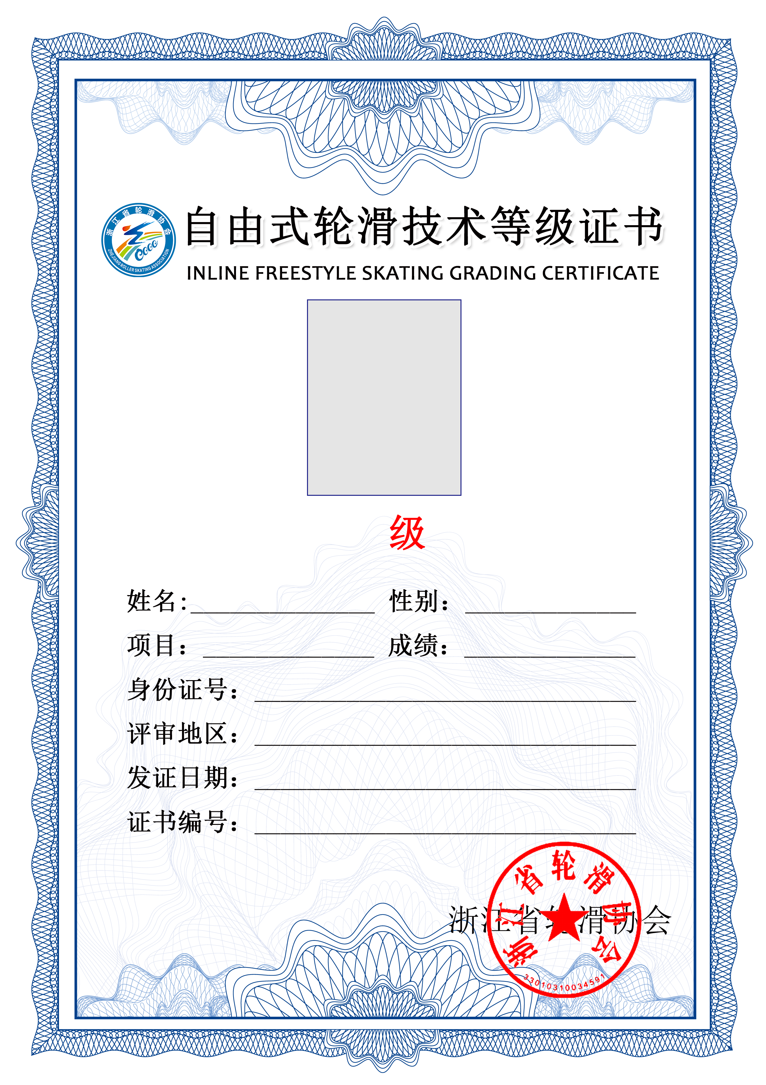

|  |  |  |  |  |  |  |  |  |
| --- | --- | --- | --- | --- | --- | --- | --- | --- |
|  |  |  |  |  |  |  | |  |
|  |  |  |  | ${photo}[100,100] | |  | |  |
|  |  |  |  |  | |  | |  |
|  |  |  |  | ${level} | |  | |  |
|  |  |  |  |  | |  | |  |
|  |  | ${name} | | |  | ${sex} | |  |
|  |  |  | | |  |  | |  |
|  |  |  | ${idcard} | | | |  |  |
|  |  |  |  | | | |  |  |
|  |  |  |  | | | |  |  |
|  |  |  |  | | | |  |  |